1. The software application I will be using for this assignment is TikTok. The Version of TikTok I will be referencing is the mobile version for iPhone. These steps may be different on different versions of TikTok
2. Use Case Diagram

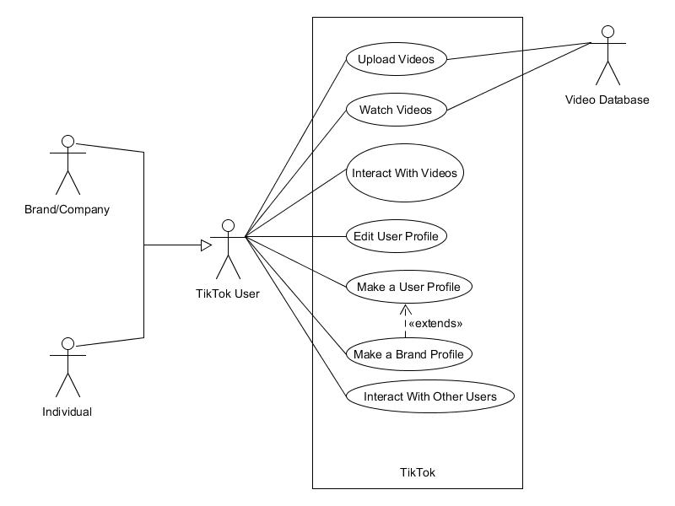

1. Use Case Templet

|  |  |  |
| --- | --- | --- |
| **Use Case ID** | UC-1 | |
| **Use Case Name** | Upload Video | |
| **Brief Description** |  | |
| **Frequency of Use** | Low – 10% | |
| **Priority** | High | |
| **Current Version** | 1.0 | |
| **Date of First Version** | 4/18/2023 | |
| **Date of Last Version** | 4/18/2023 | |
| **Created By** | Kevin White | |
| **Last Update By** | Kevin White | |
| **Approved By** | Kevin White | |
| **Assumptions** | The system is in fully working condition.  The user has already created a TikTok account.  The user is using an iPhone | |
| **Primary Actor** | TikTok User | |
| **Secondary Actor/s** | TikTok Brand | |
| **Preconditions** | The user has previously logged into the system on their Phone.  The user has already made an account | |
| **Postconditions** | The user will upload a video | |
| **Trigger** | N/A | |
| **Main Success Scenario** | **User Actions** | **System Actions** |
|  | 1. The User opens the application on their system  5. The user selects the + icon at the bottom of the screen  7. The User Records a Video  8. The user selects Audio  10. The user searches for an audio  12. The user selects an audio  14. The selects “Next”  16. The user adds a description in the description text box  17. The user selects “Post” | 2. The system gets userID, and MAC address from the users device.  3. If the userID and MAC exist in the database, the user will be automatically logged in.  4. The system pulls up the Home/For you page for TikTok  6. The system opens the video creator for TikTok  9. The system opens up a search for different audios available for the video  11. The system shows filtered audios based on the users search  13. the system adds the audio to the video made by the user  15. The system pulls up a posting page  18. The system uploads the user’s video to the TikTok database |
| **Alternate Scenarios** | **User Actions** | **System Actions** |
|  | 16.a. The user sets the video to “Friends Only” 17.a the user adds a description in the text box  18.a The user selects publish | 19.The system blacklists video from All TikTok Users  20. The system checks users Friends list  21. The system whitelists all Friends and the user to see the video  22. The system uploads the users’ video to the TikTok database. |
| **Additional Notes (Constraints, etc.)** | N/A | |

1. Test Case

|  |  |
| --- | --- |
| **Test Case ID** | TC-1 |
| **Test Case Name** | User Interface Usability Testing |
| **Brief Description** | This test case verifys that the user interface Is intuitive to use and not too confusing for the user |
| **Planned Test Duration** | 20 Minutes |
| **Current Version** | 1.0 |
| **Date of Last Version** | 4/18/2023 |
| **Created By** | Kevin White |
| **Last Update By** | Kevin White |
| **Approved By** | Kevin White |
| **The version of Software Under Test** | 1.0 |
| **Test Engineer to Conduct the Test** | Kevin White |
| **List of Test Support Software** | Apple IOS 16 |
| **List of Test Support Hardware** | iPhone 11 |

* 1. **Test Case 1 Scenario**

|  |  |  |  |
| --- | --- | --- | --- |
| Test Step Number | Input | Expected | Result (Pass/Fail) |
| 1 | Run the application. | The application starts running. | Pass |
| 2 | Swipe up on the screen | The system shows the user a new video | Pass |
| 3 | Double tap on the screen | The system displays a red Heart, and likes the video | Pass |
| 4 | Tap the chat icon in the bottom right-hand corner | System pulls up comments window | Pass |
| 5 | Type “Great Video” in the comments textbox and hit “comment” | System uploads “Great Video” under the current user’s username | Pass |
| 6 | Tap the Videos creator Headshot | The system pulls up the video creators’ profile | Pass |
| 7 | Tap the “Follow Button” | The system logs the video creators account into the current users follow list | Pass |
| 8 | Tap the “+” Button at the bottom of the screen | The system pulls up the video creator | Pass |
| 9 | Tap and hold the circle at the bottom of the screen | The system records a video using the currently selected camera | Pass |
| 10 | Select the “Next” button | The system goes to the “post” page | Pass |
| 11 | Select “Post” | The system posts the video to TikTok databases | Pass |